

EFFECTS OF POOR HYGIENE AND SANITATION PRACTICES AMONG ADULTS AGED 18-45 YEARS OF ABYEI COMMUNITY, SOUTH SUDAN

BY
KERUBINO GARANG DENG
REG. NO: AIPMS/242/2019IPMS/242/2019

A RESEARCH REPORT SUBMITTED TO NATIONAL HEALTH PROFESSIONAL EXAMINATION BOARD REPUBLIC OF SOUTH SUDAN THROUGH (AFRICAN INSTITUTE FOR PROJECT MANAGEMENT STUDIES AIPMS) HEALTH SCIENCES INSTITUTE IN PARTIAL FULFILLMENT OF THE REQUIREMENT FOR THE AWARD OF DIPLOMA IN PUBLIC HEALTH.

SEPTEMBER 2019

TITLE PAGE
EFFECTS OF POOR HYGIENE AND SANITATION AMONG ABYEI COMMUNITY, SOUTH SUDAN

BY
KERUBINO GARANG DENG
REG. NO: AIPMS/242/2019

A research Report submitted to National Health Professional Examination Board Republic of South Sudan through (African Institute for Project Management Studies AIPMS) health Sciences Institute in partial fulfillment of the requirement for the Award of Diploma in Public Health

SEPTEMBER 2019.

ACKNOWLEDGEMENT
My since appreciation goes to the almighty God for being with me, protecting me and giving me knowledge during my studies and helps me always to achieve my goals. My great thank goes to the leadership of Abyei community and Abyei Special Administrative area leadership for helping me through to achieve this greatest research for without them, this would have not been possible.
Secondly, I would like to extent my sincere appreciation to all teaching staff of African Institute for Project Management Studies AIPMS and more especially Mrs. Lucy Chege principal of Institute and the entire academics team who always encourage student to concentrate on their studies and to conduct good research. I also acknowledge the role-play by supervisor who has been advising me on how to conduct my research successfully.

DECLARATION
This research report is my original work and has not been presented for any diploma or degree in any other training institution or university.

SIGNATURE: KERUBINO GARANG DENG DATE: 03/10/2019
KERUBINO GARANG DENG REG NO: AIPMS/242/2019

CERTIFICATION
I undersigned, certify that this report is the work of the candidate carried out during his studies under my direct supervision.
I certify that I have read and hereby recommend for the examination of the research titled
Effects of poor hygiene and sanitation practices among Abyei community.
Signature………………………………. Date……………………………………
Mr.……………………………….. (Supervisor)

DEDICATION
I dedicate this thesis to my wives Mary Aluol and Elisabeth Achech Amol with love and sacrifice that has been of a great source of inspiration. Finally, I dedicate this thesis to all children being Anuei, Awan Achai, Achai and Atiek respectively.

LIST OF ABBREVIATIONS
SPSS: Statistical Package for Social Sciences
WHO: World Health Organization
MOH: Ministry of health
PHCC: Primary health care Centre
SMOH: State ministry of health
AHSI: Abyei health science institute
UNICEF: United Nations Children Funds
WHO: World Health Organization
IOM: International Organization for migration
ASAA: Abyei Special Administrative Area
WASH: Water Hygiene and Sanitation
USAID: United State Agency for International Development
UNDP: United Nations Development program
OD: Open defecation
WSP: Water and Sanitation Program
GDP: Gross Domestic Products
KAS: Kampala Declaration on Sanitation
ISH: Improvement on Sanitation and Hygiene
NDP: National Development Plan
CLTS: Community Led Total Sanitation
PHASE: Personal Hygiene and Sanitation Education
SANMARK: Sanitation Marketing
CHAST: Children Hygiene and Sanitation Training
PHAST: Participatory Hygiene and Sanitation Transformation

OPERATIONAL DEFINITION
Hygiene: according to WHO, Hygiene refer to the conditions and practices that help to maintain health and prevent the spread of diseases.
Sanitation: sanitation refers to proper disposal of both human and animal wastes that is solid and liquid wastes. It also includes disposal hazardous wastes from hospitals, industries and other sources, use and proper maintenance of toilets, and avoiding of open defecation.
Community: Community is a self-organized network with common agenda, interest, cause, who collaborate by sharing ideas, information, and other resources together.
Sanitary practices: this refers to the action of keeping things and environment clean, hygienic, and healthy by providing a proper sewage system, drainage system and supply of clean drinking water.

LIST OF TABLES
Table 1 showing Age categories of respondents……………………………………………...
Table 2 showing respondents who ………………………………………………………….

Table 3 shows how respondents……………………………………………………………...

Table 4 shows how respondents …………………………………………………………...

LIST OF FIGURES
Figure 1 showing gender of respondents………………………………………………………
Figure 2 showing Marital status of respondents………………………………………………
Figure 3 showing Level of education of the respondents………………………………………
Figure 4 showing Residence of respondents……………………………………………………
Figure 5 showing knowledge of respondents about…………………………………………..
Figure 6 shows respondents have ever been infected with ……………………………...
Figure 7 shows respondents who have been infected with …………………………………...
Figure 8 shows respondents how ………………………………………………………..
Figure 9 showing ……………………………………………………………………….......
Figure 10 showing respondents with …………………………………………………………..
Figure 11 showing respondents who use …………………………………………………….

ABSTRACT
Abstract:
Background: Inadequate sanitation has direct effect on health of individual, family, communities
and nation as a whole. Objective: To assess the effects of poor hygiene and sanitary practices of the
Abyei Community. Methods: The cross sectional study was done in Abyei community,South Sudan. A total of 80 households were randomly selected from two villages of Abyei community. The data were collected by interview method using interview and questionnaire. Data were entered in Excel sheet and analyzed on SPSS program.
Results: Many respondents (61%) were unable to read and write, 33% involved in private job of business. Knowledge of personal hygiene was high (58%) but only 35% of them were using soap water for hand washing. There was significant association between education and toilet facilities among community people. Conclusion: The knowledge regarding sanitation was high among community people but very poor in practice.
Key words: Poor hygiene, Sanitation practices, Rural area, Abyei Community.

Table of Contents
Declaration i
Certification ii
Dedication iii
Acknowledgement iv
Abstract v
List of Tables vi
List of Figure vii
List of Acronyms viii
CHAPTER 1 1
INTRODUCTION 14
1.0 Introduction 14
1.1 Background of study 14
1.2 Statement of the problem 16
1.3 Justifications of the research 18
1.4.0 Research Questions 19
1.4.1 Broad question 19
1.4.2 Specific questions 19
1.5 Significance of the research 19
1.6.0 broad objective 19
1.6.1. Specific Objectives 19
1.7 Scopes of the study 19
CHAPTER TWO 20
LITERATURE REVIEW 20
2.0 Introduction 20
2.1.0 Factors contributing to . 21
2.1.1 Prevalence 21
2.1.2 Awareness factors 21
2.1.3preventive factors 22
Chapter 3 24
Research methodology 24
3.0 Introduction 24
3.1.0 Research design 24
3.2 Study area 24
3.3 Target population 24
3.4 Study unit 24
3.5 Sample size 25
3.6 Sampling techniques 25
3.7.0 Variable 25
3.7.1 Dependent variables:. 25
3.7.2 Independent variables 26
3.8 Data collection and study instruments 26
3.9 Data presentation, analysis and interpretation 26
3.10 Quality control 27
3.11. Ethical consideration 27
3.12 Limitations 27
3.13 Dissemination of results 27
CHAPTER 4 28
DATA PRESENTATION OF THE FINDINGS 28
4.1 Introduction 28
4.1.1 Demographic of Respondents 29
4.2.0 Factors contributing to poor hygiene and sanitation among adult aged 18-45 years in Abyei . 29
CHAPTER 5 42
FINDINGS OF THE STUDY 42
5.0 Introduction 42
5.1 Key Findings 42
CHAPTER 6 45
SUMMARY, RECOMMENDATION AND CONCLUSION 45
6.0 Introduction 45
6.1 Summary of the Study 45
6.2 Recommendations 46
6.3 Conclusion 46
References 47
APPENDICES 49
Appendix I: Work Plan 49
Appendix II: Research Budget. 50
Appendix III: Letter of introduction for participants 51
Appendix IV: Questionnaires for respondents 53
Appendix V: Map of the study site 55
Appendix VI. Introduction letter for Researc ……………………………………………56

CHAPTER ONE: INTRODUCTION
- Introduction
Sanitation generally refers to the provision of facilities and services for the safe disposal of human urine and feces. Inadequate or poor sanitation is a major cause of disease worldwide and improving sanitation is known to have a significant beneficial impact on health both in households and across communities.
The word 'sanitation' also refers to the maintenance of hygienic conditions, through services such as garbage collection and wastewater disposal” (WHO, 2008). Solid wastes, domestic wastes, industrial wastes, agriculture wastes are also harmful for public health. In developed countries, typically people have use preventive measures of safety and strategy e.g. Sewerage and wastewater treatment, simple technologies, hand washing with soap to overcome the issue of poor sanitation system but in developing countries this problem impact on communities and people.(George Tchobanoglous and Frank Kreith, 2002).
Sanitation includes use of latrine, personal hygiene, clean surrounding, proper disposal of solid and liquid wastages and hygienic behavior. Toilet is taken as an essential and basic indicator of health and sanitation worldwide (Environmental sanitation guidelines,2009).Inadequate sanitation has direct effect on health of individual, family, communities and nation as a whole. Simply, having sanitation facilities increases health well-being and economic productivity.
Proper sanitation is a necessary prerequisite for improvement in general health standards, productivity of labour force and good quality of life(Sharma A. N,2007). Every 20 seconds, a child around the world dies as a result of poor sanitation(WHO/UNICEF,2008).
About 80% of all disease of the developing world is related to unsafe water and inadequate sanitation(Thapa M,1999). Worldwide, 5.3% of all deaths and 6.8% of all disability are caused by poor sanitation, poor hygiene and unsafe water. Nearly two-thirds (67%) of the total population go for open-air defecation and only one-third (33%) having access to a latrine(Ahmed MF,2001). The lack of access to sanitation in South Sudan is striking and a total of 75% of the population is without access to sanitation, one of the highest proportions in Africa.
However, the urban sanitation coverage is 75% and the rural sanitation coverage is only 20% (Patrick Webb,2007). Every day, over 60% of the population practice open defecation because they have no toilets(Nepal MDG Progress Report, 2010). Access to sanitary system, garbage disposal and toilets are lowest among the poorest population and is better in the better in urban population.
There is huge gap in access to sanitary facilities between that available to the poorest population and the national average (World Bank ,2007). So this study aims to find out the effects of poor hygiene and sanitary practices among Abyei community, South Sudan.
Hand hygiene is focuses as hand washing or washing hands with soap and water. (Bloomfield, 2007). In the most developing countries where water is not available; there are suitable solutions, such as mud and ash are alternative source of soap. It is also recommended innovation at grass-root level in this situation.
1.1 Background to the study
Poor sanitation and hygiene has direct effect on health of individual, family, communities and nation as a whole. Simply, having sanitation facilities and proper hygiene practices increases health well-being and economic productivity. Sanitation and hygiene includes proper use of latrines, personal hygiene, clean surrounding, proper disposal of solid and liquid wastages and hygienic behavior. Toilet is taken as an essential and basic indicator of health and sanitation worldwide (Environmental guidelines,2009).
Proper sanitation and hygiene are a prerequisite for improvement in general health standards, productivity of labour force and good quality of life too. Every 20 seconds, a child around the world dies as a result of poor sanitation and hygiene (WHO/UNICEF,2010).About 80% of all disease of the developing world is related to unsafe water and inadequate sanitation (ThapaM,etal1999).Worldwide, 5.3% of all deaths and 6.8% of all disability are caused by poor sanitation, poor hygiene and unsafe water.
The problem of sanitation and hygiene is not the problem of a city or country; it is problem of the whole world instead. Definitely, this is why the efforts are being made by the United Nations to avoid or resolve the problems of poor sanitation and hygiene. For this purpose, UNICEF and WHO are putting their best efforts to tackle these threats to the whole world, to adult male and females but also to the children around the world.
Unfortunately, every year, millions of people die due to poor conditions of sanitation and hygiene and because of not having desirable hygienic conditions inside, outside and in wider environment surrounding their homes.
Nearly two-thirds (67%) of the total population go for open-air defecation and only one-third (33%) having access to a latrine (Ahmed MF, etal2001). The lack of access to sanitation in Abyei is striking. 75% of the population is without access to sanitation, one of the highest proportions in Abyei and South Sudan as a whole.
However, the urban sanitation coverage is 75% and the rural sanitation coverage is only 20% (Patrick Webb,2005). Every day, 7 million South Sudanese (around 88%) of the population of 8 million people according to the 2008 population census) practice open defecation because they have no toilets (UNDP,2009). Access to sanitary system, garbage disposal and toilets are lowest among the poorest population and is better in the richer quintiles of the population.
There is huge gap in access to sanitary facilities between that available to the poorest population and the national average (World Bank, 2007). So this study aims to find out the poor hygiene and sanitary practices among Abyei community.

1.2 Problem statement
South Sudan continues to be affected by conflict in some areas and the threat of conflict in others. This situation, coupled with a long-standing environment of poverty, lack of infrastructure and food insecurity, has caused mass displacement.

This has occurred in an atmosphere where WASH coverage is also still very low at 50% coverage with basic water supply, 10% coverage with basic sanitation and with 61% of the population still practicing open defecation according to the UNICEF/WHO, 2017 Joint Monitoring Programme.

The situation is further compounded by the lack of sustainable operational and maintenance of WASH facilities. UNICEF continues to prioritize the provision of accessible, improved and sustainable WASH services which are essential for all humanitarian, recovery and development interventions .UNICEF’s activities on the ground include rehabilitating, upgrading and constructing new critical water supply infrastructure and management support for operation and maintenance(O&M),improved hygiene and sanitation services which will have an impact on improving the health and wellbeing of children and women, vulnerable groups including malnourished children.
South Sudan is hard hit by poor access to clean water, lack of basic sanitary facilities and practices, and the high costs of health care, all contributing to a high toll of infection-related illnesses. Despite enjoying various sources of support from different donors, large population especially those living in rural and per urban centers continue to suffer from various preventable diseases due to extreme poverty, inadequate healthcare and water shortages.

1.3 Conceptual framework
Independent variables Dependent variable
Increase safe access to safe WASH facilities by all group of the community (men, women, children, PWD

Awareness raising, advocacy, well-planned HP program
Increase awareness on proper utilization of available WASH facilities

Effective hygiene promotion and sanitation programs

Increase knowledge of individuals towards the effect of poor sanitary of hygiene and sanitation
Enabling environment and community to prevent communicable diseases

Ensure that sanitation facilities and hygiene promotion program are accessible to all

Narrative of the conceptual framework.
The conceptual framework was adopted from International Organisation for Migration IOM Hygiene promotion and sanitation program; the most effective ways of reducing disease transmission is to erect “primary” barriers which prevent pathogens from entering the environment. This can be done by constructing sanitation facilities, which can prevent the spread of diseases by flight and the contamination of drinking water fields and floors.
Primary intervention, which has the greatest impacts on health often, relates to the management of faeces at the household level. This because a large percentage of hygiene related activities take place in or close to the home. First step in improving hygienic practices are often easiest to implement at the household level. However, to achieve full health benefits in the interest of human dignity, other sources of contamination and disease also need to be managed.
The theory can be related with the present study considering the sanitation and hygiene of an institution. The sanitation and hygiene plays a very important role in maintaining people’s health. The individuals run the institutions and if the health of individuals is sound they can smoothly run other institutions of the society. When these institutions are being run smoothly, it leads to the institutional stability of society.
If the individuals’ health is affected by poor sanitation, their biological needs or their biological fitness will not be sound and they will not
be able to perform their role or function in institutions and the malfunctioning will disrupt the stability of other institutions in society.
Socio-demographic factors such as age, sex, marital status, level of education, and religion can affect the prevalence of brucellosis in humans. The economic status could contribute to the prevalence and access to the health facility in case of need to pay for transportation.
1.4 Justification for the study
Adult women are most commonly the water carriers (85.6%) but female children under age 15 are also significant collectors (8.8%). Beyond limited access to improved water and sanitation there is low knowledge and practice of good hygiene behaviors. The lack of access to improved water and sanitation and poor hygiene behaviors is a principal cause of water-related diseases such as diarrhea and cholera, infection from guinea worm, and contributes to malnutrition. Water, sanitation, and hygiene (WASH) is also associated with educational access and nutritional outcomes. Access to water and sanitation can be the reason why girls are kept out of school and improved access to water and sanitation at schools has been shown to increase school attendance among girls. (USAID, 2017).
Significance of the Topic
As it is understood that, poor conditions of sanitation and hygiene are quite significant problems, that had been faced by the world in the past and the present day. If an individual person becomes ill or weak because of poor sanitation and poor conditions of hygiene, then that person will not be able to work effectively in the institution ; and the result will be there that the institution will not work smoothly. Thus, without a clean toilet and poor sanitation people are forced to live in unpleasant environment.
Every year thousands of children die because of this unhygienic and unclean water by facing fatal ailments such as cholera, typhoid and other epidemic diseases. Predominantly, if the children have suffered some disease, it is usually agonizing as well as unsafe for health of other people around. Sickness takes children away from schools and adults, away from earning an income. Consequently, medical expenses make massive demands on the limited incomes of the poor.
The researcher chose this topic because it is generally believed that the conditions of sanitation and hygiene in the country are not good. South Sudan is one of the youngest developing countries and the conditions of sanitation and hygiene are not good enough for everyone, especially considering continuous conflict, poverty and insecurity of population.
1.5 Research questions
- What are the common poor practices of hygiene and sanitation among adults aged 18-45years at Abyei, South Sudan
- What is the level of awareness about hygiene and sanitation among adults aged 18-45years at Aweil civil hospital, Abyei, South Sudan.
- What preventive measures are to be done for poor hygiene and sanitation practices among adults aged 18-45 years at Abyei, South Sudan.
1.6 Research purpose
To assess the effect of poor hygiene and sanitation practices among adults aged 18-45years in Abyei, South Sudan.
This research would be of great value to Ministry of Health at national level, state level, and the County level, and others organization working in Health sectors in the community and health worker about prevention and care of sanitary diseases among adults of aged 18-45 years.
1.7.0 Research objectives
1.7.1 Research Board Objectives
To determine the effect of poor hygiene and sanitation practices among adults aged 18-45years in Abyei, South Sudan.
    - Research specific objective
The purpose of the research is to find out the effects of poor sanitation and hygiene. Particular objective of the research is
- To identify the effects of poor hygiene and sanitation practices among adults aged 18-45years in Abyei, South Sudan.
- To determine level of awareness about hygiene and sanitation practices among adults aged 18-45years in Abyei, South Sudan.
- To establish the preventive measures of proper hygiene and sanitation practices among adults aged 18-45 years in Abyei, South Sudan.
1.8 Scope of the study
The study includes participants about effects of hygiene and sanitation practices among adults aged 18-45years in Abyei, South Sudan and consented.
Participants who were under 18years, above 45 years and those under treatment or not mentally stable were excluded.

CHAPTER TWO: LITERATURE REVIEW
- Introduction
Bartlett (2003) talked about a paper that concluded that poor sanitation is harmful for children and causes if illness in them. Different researchers also researched that child mortality and morbidity rates in poor urban settlements could equal or exceed those in rural areas.
Qadri et al. (2005) concluded that ETEC (a disease) is an under recognized the reason of diarrhea in poor countries where there was insufficient clean drinking water and poor sanitation existed.
Epidemic diseases were most frequently occurring in developing countries because of different kind of bacteria that exist in children and adults living in unhygienic condition and poor sanitation.Eisenberg et al. (2007) conducted a study that diarrheal disease is because of poor quality water, unhygienic conditions and integration of these environmental control strategies. When sanitation conditions were poor, water quality improvements might have minimal impact regardless of amount of water contamination.
If each transmission pathway alone was sufficient to maintain diarrheal disease, single-pathway interventions would have minimal benefit, and ultimately an intervention would be successful only if all sufficient pathways were eliminated.
However, when one pathway was critical to maintaining the disease, public health efforts should focus on this critical pathway. The findings provided guidance in understanding how to best reduce and eliminate diarrheal disease through integrated control strategies.
2.2.0 Sanitation is a complex topic, with links to health to both social and economic development. Although it affects many, few champion it (Mara et al., 2010). Globally, sanitation is recognized as any system that promotes proper disposal of wastes, use of toilet and avoiding open space defecation (ADB, 2011; J. Bartram & S. Cairn cross, 2010). Ideally, a sustainable sanitary system should provide a clean environment that protects and promotes human health, break the disease cycle and is socio-economically viable and appropriate (Okot-Okumu & Oosterveer, 2010).
Globally, 2.5 billion people lack access to improved sanitation facilities (Unger et al., 2013), granting them unrestricted exposure to faecal contaminants and a multitude of disease. An estimation is made that 4.2% or more of the annual global mortality is preventable if all people had access to safe drinking water, reliable sanitation and decent hygiene practices (Prüss, Kay, Fewtrell, & Bartram, 2002; Tumwebaze, Orach, Niwagaba, Luthi, & Mosler, 2013). This estimation may prove hard to achieve because globally, one in every five people habitually defecate in the open or use some form of improved sanitation such as a basic hygienic latrine or a flush toilet (Jamie Bartram & Sandy Cairncross, 2010).
Much as there are numerous sanitation campaigns being implemented in rural areas, many do not often show the desired impact on communities, or a plan for their large-scale replication across the regions of need (Okot-Okumu & Oosterveer, 2010). Although the health-threatening effects of inadequate sanitation can be solved by proper budgetary allocation, fewer resources are continually committed to sanitation and hygiene (Mugambe et al., 2013; WaterAid, 2010/2011).
With only 0.37% of Uganda’s gross domestic product (GDP) allocated to water and sanitation development, the socio- economic repercussions of unsafe water and poor sanitation for Uganda is 1.1 % of the GDP. This cost is manifested through premature deaths, increased health costs, and productivity losses (Kulabako, Nalubega, Wozei, & Thunvik, 2010; Ministry of Water and Environment Uganda, 2015; Water and Sanitation Programme (WSP), 2012).
Uganda has a well-developed policy framework, originating from a constitutional provision that every Ugandan has the right to a clean and healthy environment and that it is the duty of every citizen to create and protect such an environment. Several laws, regulations, policies and strategies are in place, including the Public Health Act (1964, updated 2000), with provisions in the areas of prevention and suppression of infectious disease, sanitation and housing, as well as the protection of foodstuffs (Plan-International., 2011).
The 1999 National Health Policy emphasizes sanitation and hygiene promotion as a key public health intervention. The 2005 National Environmental Health Policy establishes environmental health priorities and provides a framework for the development of services, and programs for both national and local government levels (Plan-International., 2011). The national “Improvement of Sanitation and Hygiene (ISH) strategy” applies a three-pronged approach to increase demand for improved services through supply of services to help households benefit from better sanitation and having an enabling environment.
The 1997 Kampala Declaration on Sanitation (KDS) was endorsed by district political leaders as an indicator of the political will to see change: it defines ten areas of action to improve sanitation at district and other local government levels (Plan-International., 2011). The 2010-2015 National Development Plan (NDP) recognizes CLTS as one of the hygiene and sanitation promotion approaches in the country, although there is no specific policy direction in the country to guide the adoption and application of CLTS per se (Plan-International., 2011).
2.3.1 Approaches used
Recently, Uganda made a shift away from centrally planned (top-down) provision of sanitation towards demand-led approaches to create and serve people's motivation to improve their own sanitation (Mara et al., 2010). These initiatives include; Participatory Hygiene and Sanitation Transformation (PHAST), Personal Hygiene and Sanitation Education (PHASE) and Children Hygiene and Sanitation Transformation (CHAST), and Sanitation marketing (SANMARK).
The trainings for these interventions were carried out either by the Ministry of Health or other agencies for district and sub-county level personnel, and for WASH sector NGO staff and primary school teachers responsible for hygiene (Plan-International., 2011). Government has also spearheaded annual Home Improvement Campaigns, entailing the unpopular enforcement of byelaws and other sanctions to ensure, among others, that households construct latrines (Ministry of Water and Environment Uganda, 2015; Plan-International., 2011). PHASE centers on hygiene and sanitation training for pupils, teachers, parents, and government officials.
PHAST seeks to help communities improve hygiene behaviors; reduce diarrheal disease by effectively managing water and sanitation services. PHAST has received criticism from both its implementers and beneficiaries for applying ‘childish’ methodologies and different implementers hold an argument that PHAST could soon face abandoned due to its poor community approaches (Peal et al., 2010; Water Aid, 2010/2011; World Bank, 2010).
SANMARK uses a range of interventions to raise householders' demand for improved sanitation (Jenkins & Scott, 2007). SANMARK involves understanding householders' motivations and constraints to sanitation adoption and use. These are used to develop both demand- and supply-side interventions to ensure that appropriate sanitation products and services are available to match the demand (Mara et al., 2010; Peal et al., 2010).
2.3.2 Challenges
Open defecation is accepted and widely supported in many rural communities, especially during travels, in the fields, and due to some cultural and customary beliefs. Therefore, the success of OD may not be registered fast enough especially when dealing with children, elderly people or persons with disability as beneficiaries (R Chambers & Myers, 2016; Okot-Okumu & Oosterveer, 2010). Another emerging issue however is the sustainability/ future of ODF status as the approach utilizes local actors (VHTs, Natural leaders) for scalability and yet motivation of such volunteers continues to be a concern. These self-motivated volunteers could improve better with some motivation (Plan-International., 2011).
Another major challenge is the lack of commitment by the line ministries to institutionalize CLTS as a key approach for sanitation improvement in the national sanitation guidelines (Plan-International., 2011). The CLTS task force comprising of, Ministries of Water/Health, Water Aid Uganda, Plan International Uganda, SNV, and WSP cannot coordinate all CLTS host villages due to inadequate technical and financial challenges (Plan-International., 2011). CLTS should introduce cheap designs for toilet construction to promote its easy operation and maintenance instead of focusing only on health benefits (R Chambers & Myers, 2016; TyndaleBiscoe et al., 2013).
Also, the current sanitation investment in Uganda is between 0.1-0.5% GDP which is lower than several estimates for what is required, therefore increased investments in sanitation and hygiene promotion are required not only to realize health and welfare benefits of sanitation but also to avert large economic losses (Plan-International., 2011; Water and Sanitation Programme (WSP), 2012). This study has positive outcomes, which could be incorporated into policy frameworks on sanitation to improve outcomes across all districts in Uganda. Although there is evidence of numerous sanitation studies in Uganda, a wide knowledge gap is evident with regard to studies on positive deviance and sanitation.
Appropriate community-based health education is culturally sensitive and draws on social relationships to achieve success (Glanz, Rimer, & Viswanath, 2008; McDonald et al., 2010; Rabbi & Dey, 2013). During health sessions, the VHTs disseminated health information to participants. The participants who heeded to and followed VHT instructions regarding childhood sicknesses, managed to prevent and contain those sicknesses that had already shown signs. The VHT’s role in influencing health behaviors is not only evident in Bulo, but also traceable to the works of scholars such as (Haines et al., 2007).
As the elders continue to practice OD, other members of the communities also join in (R Chambers & Myers, 2016). Apart from faecal handling and practicing poor sanitation, elders have actively mobilized people to participate in CLTS and sometimes played the facilitation role. PDs who attended such sessions revealed that people preferred listening to elder/ family than to political leaders.
Listening to elders not only provided PDs with solutions but motivated good practice. A CLTS study in India, revealed how elders in Aasgaon discouraged open defecation by spearheading informal health sessions (Rasal & Kalshetti, 2011). In summary, much as some elders perpetuated open defecation in communities, there were those elders whose behaviors motivated better health practices.
5.3.0 Health promotion / health care resources
These are health assets stimulating positive health outcomes in a person’s life. From the research findings, both PDs and non-PDs had access to some common health resources. Such common resources included Bulo health center, which played a tremendous role in promoting maternal and infant health in the community.
A study by Waiswa, Kallander, Peterson, Tomson, and Pariyo (2010), in Uganda, revealed that delay in problem recognition and or deciding to seek care outside the home was the greatest contributor to death in infants. To address community health care challenges, some scholars agreed that, it was important to strengthen both health facility and community programmes as an essential for improving hygiene and sanitation in hard to reach areas (Haines et al., 2007; Waiswa et al., 2010).
Community health workers are described to include community-based workers, village health teams, community resource people, and workers known by local names Haines et al. (2007). The community volunteers responsible for treating and promoting domestic health in the study area were VHTs.
Research shows that the additional roles played by the VHTs have led to easy management of neonatal sepsis, promotion of healthy behaviors, and filling gaps left by the professional health workers (Glenton et al., 2013; Haines et al.,2007).
5.4.0 Role of leadership
Every organization is structured either by a formal, informal or non-formal leadership style. From findings, various leadership structures were evident in the communities. Accordingly, various leaders mobilized the communities for development activities, lobbied for projects, managed conflicts and counselled others. Study participants mentioned that through their leaders they participated in health, educational, agricultural and religious programmes.
It is clear that committed and strong leaders had motivated various community health achievements in Nawango and Bule. Kellerman (2004) argues that to assume that all good leaders are good people is to be deliberately blind to the reality that human condition severely limit our ability to become better (Kellerman, 2004).
5.5.0 Community network roles
Community as a setting was an important determinant of health outcomes. A common definition describes a community as a group of people with diverse characteristics sharing common perspectives and living in a similar setting (Leskovec, Lang, Dasgupta, & Mahoney, 2009). Although this definition best describes the study area, the experiences gathered from theses villages differed from one another. The community created a supportive environment needed for participants to involve in participatory community work. The community encouraged better health practices, for example during the walk of shame, defecation mapping, shit calculations, triggering and community meetings. Participants mentioned that the setting encouraged social interactions and responsibility.

CHAPTER THREE: METHODOLOGY
- Introduction
This chapter presents the methodology that will be used to collect relevant data. The chapter describes the research design, target population, research instruments, sample and sampling procedures, data collection procedures, and data analysis procedures.
3.1The study design
This will be a healthy facility based cross-sectional study using both qualitative and quantitative methods of data collection. It will be a cross sectional study to be carried out at Abyei…. on participants. According to Saunders et al., (2007), a cross sectional study is ideal in that it provides a point in time information that captures the opinions, attitudes, preferences, practices and factors of interest in research.
3.2 The study area

Abyei is an area of 10,546 km², a contested area between Sudan and South Sudan and is found at the border of two countries in the region of greater Bhar EL Ghazal of South Sudan and Kordufan of Sudan. It is located in the northern part with an estimated distance of 926.4 Km from capital city Juba. The community borders Abiem Nhom in the east, Northern Bhar EL Ghazal in the west, Twic state in the south and Kordufan in the north.
The study will be carried out at Abyei referral Hospitals and primary schools located in Abyei town of ASAA region of South Sudan.
  - Study population
The study population will be residents of Abyei about the effects of poor hygiene and sanitation practices among adults aged 18-45 years in Abyei, South Sudan.

Inclusion criteria
Adults aged (18-45) years residing in Abyei community.

Exclusion criteria
Any adult below 18 or above 45 years will not be considered and those too ill to respond to the interviewer will excluded from the study.
3.4 Study units
Adults aged (18-45) years settling within the areas of studies, the neighbourhood community will be in target, and it is within Abyei referral hospital and schools.

3.5 Sample size
Sample size study population was 90 adults of aged 18-35 years and was calculated using Tiruneh (2008) formula as below: by considering
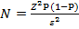Where;
N =expected minimum sample
Z = standard deviation of the normal distribution, corresponding to 95% confidence=1.96
P= considered proportion which is 65% (0.649)
ε= maximum likely error taken as 10% (0.1)
Therefore, the expected sample size was 90 patients who were included in the data collection and 1 more were added to account for error giving a total of 35 patients.
NB, 95% is constant number given.
N=1.96² * 0.75(1-0.649)/0.1²
N=1.96² * 0.75(1-0.649)/0.01
N=3.8416*0.75(0.351)/0.01
N=3.8416*0.2635/0.01
N=0.9/0.01
N=90
3.6 Sample techniques
The respondents of this study were primary selected from Abyei community. Random technique will be used to choose the individual without biasness and prejudice. Random technique is found to be suitable for this study since the identifying of factors leading to pneumonia is seemly complex. The respondents will be given a rolled paper written yes or no in it. If an individual, choose yes that respondents was included to answer the questionnaire and if an individual chose No that respondents will not be included.
3.7.0 Variables

3.7.1 Dependent variable

Poor hygiene and sanitation practices among adults aged 18-45years in Abyei, South Sudan

3.7.2 Independent variable
These include;
Individual factors of adults such as sex, age, education level, occupation, religion, seeking permission, knowledge of service programme, economic status.
3.8 Data collection and study instrument

Training of research assistants
Two research assistants will be selected and trained on the data collection tools. The selection of research assistants was based on education and training background, fluency of English, Arabic and Dinka. The training of the research assistants will be done by the principal investigator in two day’s session to ensure personnel are thoroughly familiar with the study objectives. The training sessions will include; interviewing techniques, data collection procedures, data collection tools, expectations and quality control.
Potential questions and challenges to be met in the field will also be discussed during the session. Interpretation shall also be practiced to ensure that meaning of the questions is not changed.

Tools
Quantitative data will be collected with a structured questionnaire using a face to face interview method. This data will include; Individual factors, health systems factors and programme factors associated with poor hygiene and sanitation practices among adults aged 18-45years in Abyei,South Sudan
Qualitative data will be collected using focus group discussion guide and key informant guides. The key informant guides will be administered to hospital health officials, health facility in-charges, VHTs, to obtain information on the effects of poor hygiene and sanitation practices among adults aged 18-45years in Abyei,South Sudan.
Participants will be engaged in a focus group discussion on information in line with brucellosis services.The focus group discussion will be administered by two enumerators who will be selected on basis of having previous experience in conducting FGDs and KIs as well as being fluent in the common local languages.
3.9 Data presentation, Analysis and Interpretation
The data collected were analyzed using descriptive statistical techniques, presented inform of bar graphs, frequency tables and pie-chart and summarized in narrative or statement using Microsoft office word.
All the quantitative and qualitative data in questionnaire will be sorted, edited, coded and presented in form of graphs, tables and pie charts for clear discussion of the findings.
3.10 Quality control
The questionnaire was thoroughly checked by the African Institute for Project Management Studies AIPMS to ensure the quality standard of data collection. The data collected will be reviewed to ensure the correct data entry and quality reporting. In view of potential biases arising from interviewees by virtue of the discipline they represent, we triangulated the data and information arising from the interviews using document analysis of legal documents, archival material from public health , and other published material Rizzo Naudi J.etal(2005) and Djuricic B.etal(2010).

3.11 Ethical considerations
Scientific and ethical approval for the study will be sought from African Institute for Project Management Studies AIPM and health administrators in Abyei community. Informed consent will be sought from each study participant to participate in the study.
Informed consent forms will be provided to the participants for signing prior the interview. This will be done after the interviewer has thoroughly explained the purpose of study to the study participants.
The study participant shall be assured of confidentiality for all information given as such keeping recorded tapes and questionnaires under lock and key, protecting raw data with a password on the laptop as well ensuring that names and location identifiers are avoided.
Informed consent was done as voluntary participation agreement between a researcher and the participant signed after the participant has fully understood the implications of taking part in a study (Creswell, 2014).
3.12 Limitation of the study
This study will be done in one healthy facility and therefore findings are not representative of the entire border of two countries in the region of greater Bhar EL Ghazal of South Sudan and Kordufan of Sudan. Also, factors obtained in this study will not necessarily conclude causality since this is a cross-sectional study and it’s also limited to those of aged 18-45 years.
3.13 Dissemination of results
There were 4 copies of this study printed out, the first copy for the school administration that will be in the school library, the second copy to the hospital where the study is carried out, the third copy will be retained by the researcher and fourth copy will be submitted to the National Health Professional Examination Board South Sudan as a requirement for the award of a Diploma in Public health.
The cross sectional study will be done in Abyei community, South Sudan. The study duration will be from September to October, 2019. Among them sample size 80 households were selected purposively for data collection.
The data was collected from every third house in each ward. The first house was selected randomly. For data collection, interview was conducted with the head of the household using a semi structured schedule. Observation was done using an observational checklist to assess the sanitary condition of latrines. Data was entered in excel sheet. Editing and coding was done and analyzed by using SPSS 20. The verbal consent was taken from the respondents before interview.

CHAPTER FOUR: DATA PRESENTATION OF THE FINDINGS
A total of 90 respondents were interviewed from 90 household in two villages of Abyei community, South Sudan. Among them 72% were female and 27.2% were male. Most of them (82%) were Muslim and 18 % Christian by religion. Most (61%) were unable to read and write and 33% were doing private job. Many (40%) had nuclear type of family.
4.1.0 Demographic of Respondents
This section shows age categories, gender, marital status, residence and educational level.
Table 4.1.1 showing Age categories of respondents
VARIABLE | FREQUENCY | PERCENTAGE
Years | Numbers | %
18-30 | 23 | 25.71%
31-40 | 49 | 54.29%
41-45 | 18 | 20%
The table 1 above indicated that 54.29% of respondents were from age 31-40 years, 25.71% of respondent were form 18-30 years while 20% were from 41-45 years. These findings shown that majority of respondents were from 21-30 age categories. This study was carried out among 90 participants of Abyei community.
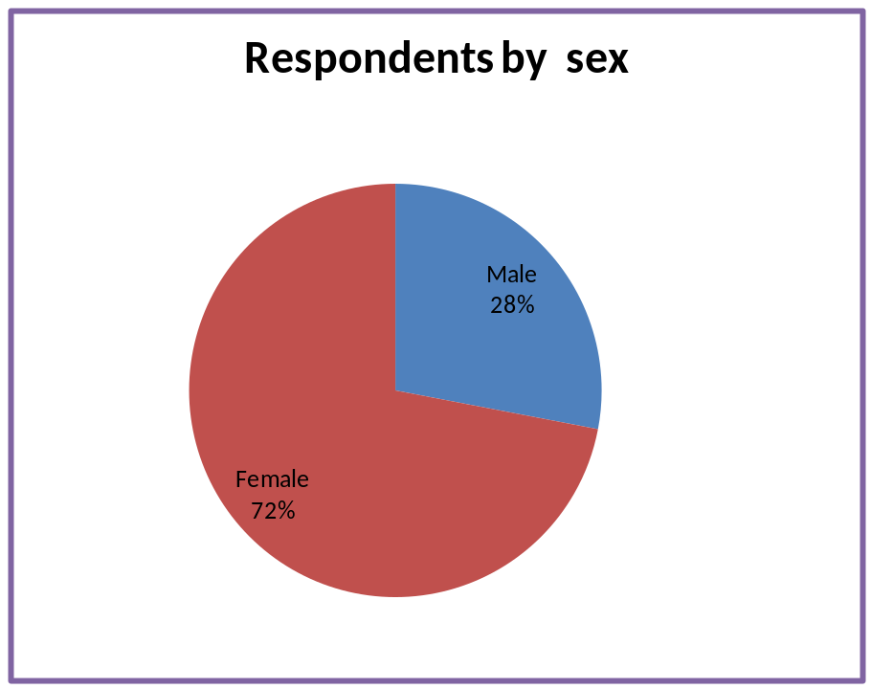
Figure 4.1.2 showing gender (sex) of respondents
Figure 1 indicated that 72% were female and 28% were male. These findings shown that majority of respondents in this study were female.
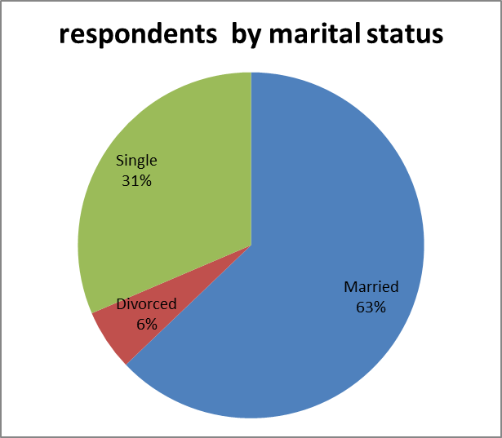

Figure 4.1.3 showing Marital status of respondents
Figure 2 above shown that 62.86% were married, 31.43% and 5.71% were divorced. These findings clearly indicated that most of respondents were married in this study.
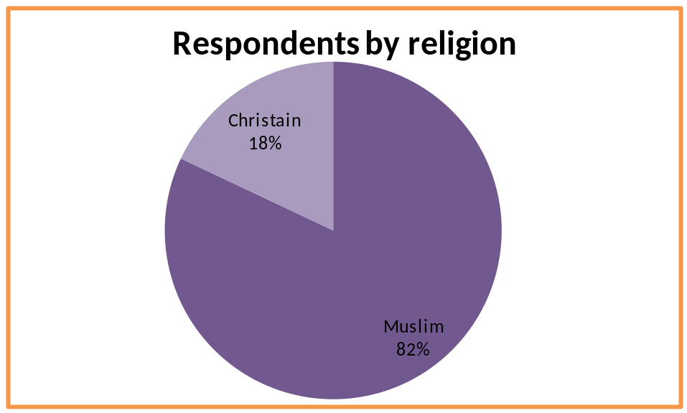
Figure 4.1.5 showing Religion of respondents
Figure 3 above shown that 82% were Muslims and 18% were Christains. These findings clearly indicated that most of respondents were Muslims in this study

Occupation | Frequency | Percentage
Agriculture | 12 | 13.3%
Government Job | 12 | 13.3%
Private Job | 50 | 55.5%
No Labour | 16 | 17.8%
Total | 90 | 100

Table 4.4.1 shows how respondents by occupation.
Table 2 study show that most of the respondents were doing private job(55.5%),No labour(17.8%),government and Agriculture both tied at 13.3% at Abyei community.
Association of toilet fac ilities with different variables
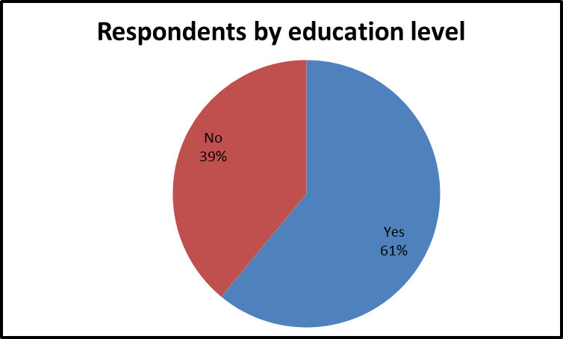
Figure 4.1.5 showing education level of respondents
Figure 4 above shown that 61% of respondents could read and write while 39% were unable to write and read. These findings clearly indicated that most of respondents were literate in this study
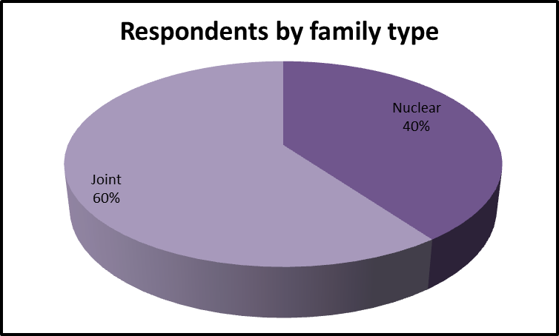
.
Figure 4.1.5 showing type of family by respondents
Figure 5 above shown that 60% were residing jointly or extended family and 40% were in nuclear family. These findings clearly indicated that most of respondents were living in extended family or jointly in this study

To identify the hygiene and sanitation practices among adults aged 18-45years in Abyei,South Sudan
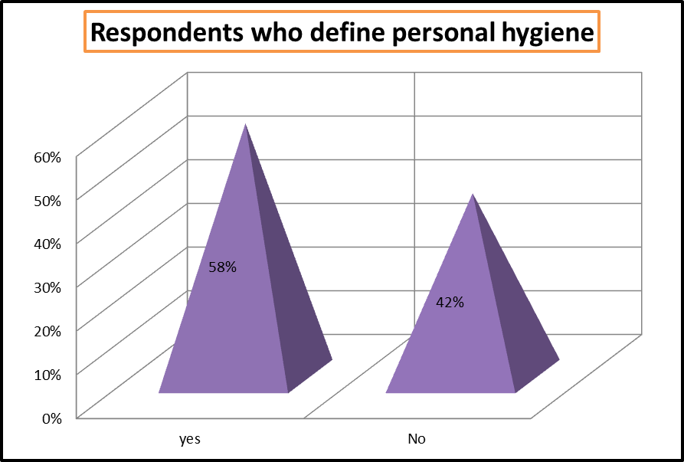
Figure 4.1.5 showing knowledge about personal hygiene by respondents
Figure 6 above shown that 58% have knowledge about personal hygiene and 42% donot know about personal hygiene. These findings clearly indicated that most of respondents were knowledgeable about personal hygiene in this study

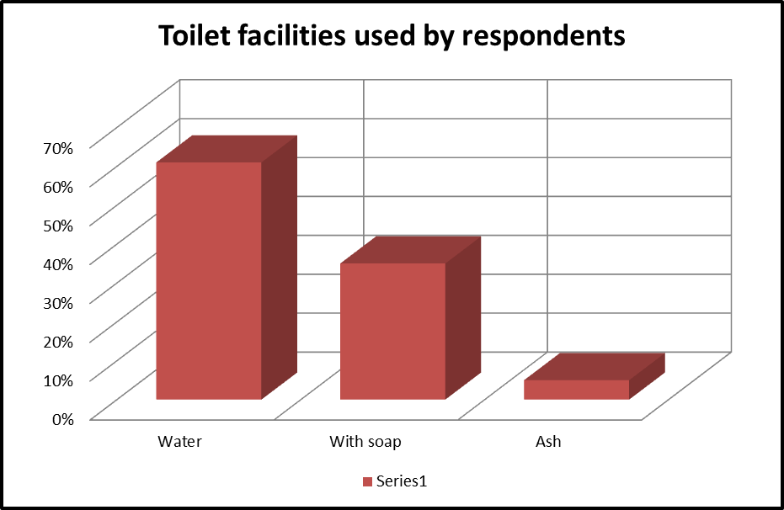
Figure 4.1.4 showing use of toilet facilities by the respondents
The figure 7 show (65%) of the respondents were using water alone after defecation, and 31% were using soap while 4% were using ash/soil water for hand washing. These findings clearly indicated that most of respondents use water only after defecation in this study.
To determine level of awareness on hygiene and sanitation practices among adults aged 18-45years in Abyei, South Sudan.
Table No.03: Percentage distribution of respondents regarding definition of sanitation
Defining Sanitation | Frequency | Percentage
Cleanliness of roads, footpaths & homes | 01 | 1.1
Collect waste, garbage from roads | 01 | 1.1
Pure food and water | 29 | 32.2
All of the above | 59 | 65.6
Total | 90 | 100
The table 3 describes that according to 65.6 percent respondents said that all the options were correct, 32.2 percent respondents said pure food and water, 1.1 percent respondent the meaning of sanitation were cleanliness of roads, footpaths and homes, and 1.1 percent said to collect waste, garbage from roads. This table shows that majority of people are aware of what sanitation is.11), Vol.1 No.2 42
Table No. 04: Percentage distribution of respondents in regard with defining waste management
Defining waste management | Frequency | Percentage
Collect & shift waste out of the home | 35 | 38.9
To re-cycle the waste | 01 | 1.1
All of these | 54 | 60.0
Total | 90 | 100
The table 4 describes that 60.00 percent said that all the options were correct, 38.9 percent respondents meant the waste management to collect and shift waste out of the homes and 1.1 percent said that to recycle the waste.
Table No. 05: Percentage distribution of respondents in regard with their awareness of the effects of poor sanitation.
Effects of poor sanitation | Frequency | Percentage
To great extent | 62 | 28.9
To some extent | 2 | 2.2
Don't know | 26 | 32.2
Total | 90 | 100
The table 5 reveals that 68.9 percent respondents were aware of the effects of poor sanitation to great extent and 28.9 percent respondents were aware to some extent while 2.2 percent respondents did not know the effects of poor sanitation. It means that a majority of people was aware of effects of poor sanitation. The awareness of effects of poor sanitation is good for people because they can avoid these affects.
To establish the preventive measures of proper hygiene and sanitation practices among adults aged 18-45 years in Abyei, South Sudan.
Table No. 06: Percentage distribution of respondents regarding their submission of complaints against poor sanitation
Complaints against poor sanitation | Frequency | Percentage
Daily | 03 | 3.3
Twice in a week | 01 | 1.1
Once in a month | 18 | 20.0
Several time in a month | 11 | 12.2
Total | 90 | 100
The table 6 explains about 20.00 percent submit complaints once in a month,12.2 percent do several times in a month, 3.3 percent submit complaints daily and 1.1 percent submits twice in a week. This negligence leads to no attention of administration and will cause poor sanitation in the area.
Figure No. 08: Percentage distribution of respondents in regard with shifting the waste outside the house.
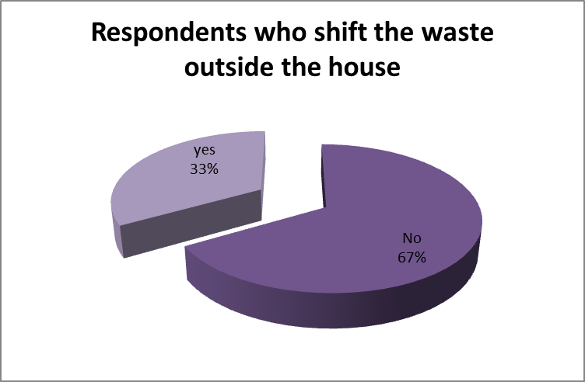
The figure 8 shows the responses of individuals to workers in which 66.7 percent workers placed the waste outside the house and 33.3 percent respondents said that the waste was not being shifted outside the house.
Table No. 07: Percentage distribution of respondents explaining the cleaning of public toilets
Cleaning of public toilets | Frequency | Percentage
Daily | 08 | 8.9
Once in a week | 09 | 10.0
Once in a month | 07 | 7.8
On special occasions | 05 | 5.6
Total | 61 | 67.8
Total | 90 | 100
In this table 7 show that 67.8 percent respondents the sanitary workers cleaned the toilets on special occasions, according to 10.00 percent, toilets were cleaned twice in a week, 8.9 percent respondents said that sanitary workers clean the public toilets daily., according to 7.8 percent respondents toilets were cleaned once in a week,according to 5.6 percent toilets were cleaned once in a month. Proper cleaning will be helpful in preventing diseases.
Percentage distribution of respondents explaining the need fulfillment of drinking water provided by administration
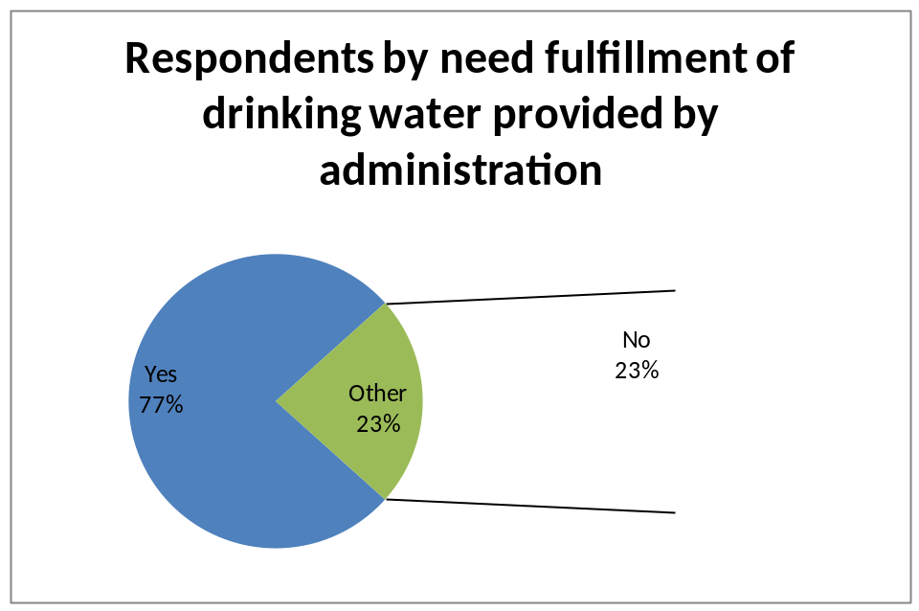
In table 9 show that respondents talked about the fulfillment of their need of drinking water provided by administration. According to 76.7 percent respondents told that the supplied water fulfilled their need while 23.3 percent respondents said that the water did not fulfill their need of drinking water.
Table No. 08: Percentage distribution of respondents in regard with having a kind of sewerage and drainage system
Sewerage and drainage system | Frequency | Percentage
Better | 05 | 5.6
Good | 37 | 41.1
Not Bad | 16 | 17.8
Poor | 32 | 35.6
Total | 90 | 100
The table 8 describes the situation of sewerage and drainage system in the area in which 41.1 percent respondents had good, 35.6 percent respondents had poor drainage and sewerage system, 17.8 percent respondents said that their sewerage and drainage system was not bad and 5.6 percent respondents said that they had a better sewerage system. If system is good then there will be no wastewater on the roads and less chances of spread of disease.

Table No. 09: Percentage distribution of respondents explaining the duration of remaining the wastewater on the roads, home compounds, or footpaths
Wastewater on roads | Frequency | Percentage
Two days | 11 | 12.2
Five Days | 05 | 5.6
The Whole Week | 01 | 1.1
More than a Week | 35 | 38.9
No | 38 | 42.2
Total | 90 | 100
In table 9 indicate that duration of remaining the wastewater on the roads or homes in the areas where there are poor conditions of sanitation. The 42.2 percent respondents said that no wastewater was being spread on the roads or streets in their area, 38.9 percent respondents said that the wastewater remained on the roads more than a week, 12.2 percents respondents said that the wastewater remained on the roads or homes in their area for two days. 5.6 percent respondents said that the wastewater remained on roads for five days and 1.1 percent respondents said that it remained for one week.

Figure No. 10: Percentage distribution of respondents regarding their response if the poor sanitation was responsible for diseases
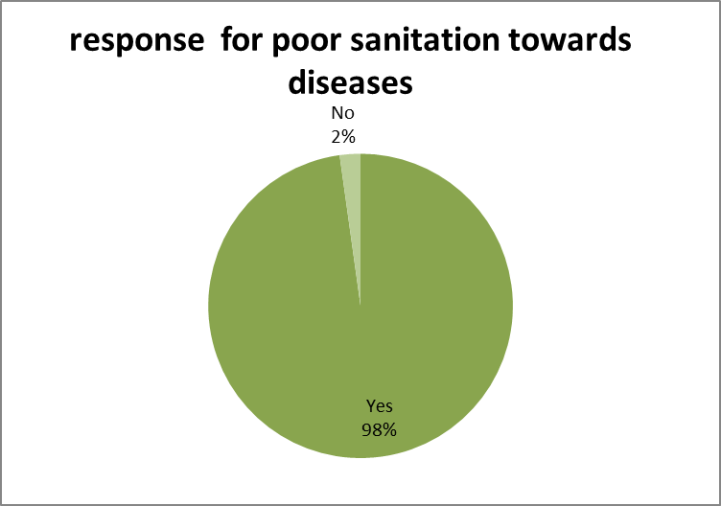
The figure 10 show that responses from different respondents about the cause of spread of the diseases because of the poor sanitation in which 97.8 percent respondents said that the poor sanitation was responsible for diseases and bad health. This relates to our hypothesis. 2.2 percent respondents said that poor sanitation was not responsible for diseases.

CHAPTER FIVE: DISCUSSION OF FINDINGS

5.0 Introduction

In this chapter is a presentation of discussion of results in relation to literature review. The discussion is guided by the research questions and objectives of the study and the results obtained in the study.

5.1 Key Findings
Objective 1: To identify the hygiene and sanitation practices among adults aged 18-45years in Abyei,South Sudan.
In this study most (65%) of the respondents were using water alone after defecation, and 31% were using soap while 4% were using ash/soil water for hand washing.
But the study done in Madhya Pradesh India showed that 100% of people did not wash their hand after defecation they were using stone, soil and leaves for washing hand. (Sharma A. N, 2007).
Similarly, the study done in Kathmandu, showed that majority (36%) of the households had used soap with water after defecation (Pradhan Bandana, 2008). As hand washing is directly concerned with personal hygiene, it is good practice that this community was using soap plus water of 65% after defecation.
Similarly the study done in Madhya Pradesh showed that environmental sanitation through inhabitants was of an average degree, but not very much satisfactory from the hygiene point of view(Sharma A. N,2007).
The present study shows that 80% awareness about sanitation but the studies done in Bote community of Pragatinagar VDC of Nawal parasi district showed that only 15% of respondents were aware of
hygiene. Most of them believe that ghosts spread of diseases (Rosyara KP, 2009).
In this study 67% of the houses didn’t had toilet facilities and they use open defecation. According to (USAID-WASH, 2018) progress report, around 65% of the population of South Sudan practice open defecation because they had no toilets.
Similarly, the study done by Kravid DZ showed that only 5% of villagers used latrines. (Kravitz JD,1995). In the study done by Thapa M showed that in most of the rural village, latrines are non-existent. The people used to discharge excreta near water sources, making water contaminated (Sharma AP, 2009).
Poor handling of faecal matter pose high risk of diarrheal diseases due to wide spread contamination, death or chronic stomach ulcers (Prüss et al., 2002). Among some ethnic groups in Uganda, elderly in-laws and pregnant women are forbidden to use latrines (Robert Chambers, 2009; Okot-Okumu & Oosterveer, 2010), these cultural taboo promote shame and negative attitudes towards active participation in health campaigns and other activities to improve sanitary practices (Okot-Okumu & Oosterveer, 2010).
According to reports, such shared toilets are habitually filthy and disgusting to use, making them unpleasant to clean thus a provocation to relapse to open defecation (OD) (Barnard et al., 2013; R Chambers & Myers, 2016). Recent debates concerning the post-2015 development agenda have drawn attention to neglected diseases and have focused on the importance of consensus regarding Water, Sanitation, and Hygiene (WASH) targets and indicators (Bastien et al., 2016).
In sub-Saharan Africa for example, access to basic sanitation was identified as one of the most off-track Millennium Development Goals (ADB, 2011; Fewtrell et al., 2005; WHO & UNICEF, 2014). And the anticipated health benefits such as; reduction in the direct cost of hospitalization, burial costs, increased household income and safe food for consumption are increasingly hard to meet (Esrey, Potash, Roberts, & Shiff, 1991; Mugambe et al., 2013).
Objective 2: To determine level of awareness on hygiene and sanitation practices among adults aged 18-45years in Abyei, South Sudan.
According to Chambers and Myers (2016), understanding and identifying the social norm, cultures and deviants create awareness of taboos, beliefs and prohibitions that could be used to inform behaviors change (R Chambers & Myers, 2016).
Accordingly, various leaders mobilized the communities for development activities, lobbied for projects, managed conflicts and counselled others. Study participants mentioned that through their leaders they participated in health, educational, agricultural and religious programmes Kellerman (2004).
A report by WHO/UNICEF also states that since the adoption of the CLTS, open defecation rates declined globally from 24% in 1990 to 15% in 2011 (WHO & UNICEF, 2014). Although the decline differs from region to region, countries mostly in Eastern/South-eastern Asia and the Latin America/Caribbean have all registered steady declines. In sub-Saharan Africa at least 26 countries introduced the approach with 5 countries adopting it in their national sanitation strategies (Kar & Milward, 2011). This interesting move by the sub-Saharan Africa has not prevented the region from registering new open defecation cases daily (WHO & UNICEF, 2014).
Research reveals that, people are well aware of the need for basic hygiene practices, and do not need criticisms and harassments to change as is the case in Uganda (Peal et al., 2010). It focuses on sanitation and hygiene behavior change, in contrast with conventional approaches to improved sanitation by typically involving household subsidies for infrastructure -which have proven neither scalable nor sustainable (R Chambers & Myers, 2016; Plan-International., 2011).
Objective 3: To establish the preventive measures of proper hygiene and sanitation practices among adults aged 18-45 years in Abyei, South Sudan.
According to Coe, Keller, and Walker (2015), the most appropriate and effective format for teaching health behaviors is either parental, one-on-one teaching or family-oriented (Coe et al., 2015). Religion, spirituality, medicine, mental health, neonatal death for the infant, and healthcare have been related in one way or another in all population groups since the beginning of recorded history (Coe et al., 2015; Guilfoyle & St Pierre-Hansen, 2012; Koenig, 2012).
A study by Coe et al. (2015) showed that the churches promoted the health of individuals through teaching health behaviors to people, a finding related to participant responses from the study. Participants reported that religion motivated them to learnt and respect what their leaders said regarding health. PDs revealed that they attained good health with encouragement and lessons from their relatives.
Another study by Nepal and Karki (2006), also revealed that children motivated their elders to stop practicing open defecation by chanting pro-sanitation slogans, blowing slogans and publishing their names. The extended families such as uncles, aunts and grannies acted as learning avenues for study participants. Behaviors learned included various health practices.
These success stories are similar to findings by a Water Aid and Vatsalya community-based menstrual hygiene and WASH programme in utter Pradesh, where boys and men supported effective menstrual hygiene in India (Sahin, Mahon, Tripathy, & Singh, 2015).
It is believed that health promotion practices that engage all members in the community using practical strategies, achieve faster behavior change (McDonald et al., 2010). Yet the CLTS implementer at the district revealed that, due to inadequate time and resources, there was no equal involvement and participation of all beneficiaries.

CHAPTER SIX: SUMMARY, RECOMMENDATION AND CONCLUSION

6.0 Introduction
This part summarized the findings, implication, recommendations and conclusion of the study.

6.1 Summary of the Study
The sanitary knowledge 58% and hand washing with soap water 35% of the community people was high. The toilet facility was low (36%). The above table’s results show that there is relationship between conditions of sanitation and the spread of diseases. The gamma value is negative which shows that as the conditions of sanitation start being better, there are less chances of spread of disease. Drinking quality water remains an important issue not only in poor communities but also for the urban slums in South Sudan; even at European Countries it is estimated that 120 million people do not have access to safe drinking water because water quality is poor. (Clasen and Haller, 2008). Similarly, poor sanitation is the major reason of epidemic disease specially for third world countries.
The objectives of the study were to determine the effect of poor sanitation and hygiene practices in the smooth functioning of community, to identify what role was played by sanitation and hygiene in community and to find out how the poor conditions of sanitation and hygiene affect the working environment of Abyei community bordering South Sudan and North Sudan.
A great number of respondents were aware of the effects of poor sanitation for instance people getting sick and were being migrated, catching diseases and were bearing economic loss because of poor sanitation.

6.2 Recommendations

There should be extensive health education program for the people of the Abyei Community about the better personal hygiene and sanitation practices.
Government and Non-governmental organization should be involved in the construction of toilet in this community with their full participation.
Civic awareness of the whole community through cultural meeting focus group discussions, seminars, workshops, local media platforms about good sanitation and hygiene practices in the area.

6.3 Conclusion
The study established that 97.8% of respondents said that the poor sanitation was responsible for diseases and bad health while 2.2% respondents said that poor sanitation was not responsible for diseases.
From over all study of the research, it was concluded that the sanitation and hygiene has a great importance in the society. The findings concluded that a relationship exist between conditions of sanitation and the cause of diseases. Moreover, when conditions of sanitation start to get better then causes of diseases reduce.

References
ADB. (2011). African Development Bank: Uganda Water Supply and Sanitation Programme.
Bartram, J., & Cairncross, S. (2010). Hygiene, sanitation, and water: forgotten foundations of
health. PLoS Med, 7. doi:10.1371/journal.pmed.1000367
Bartram, J., & Cairncross, S. (2010). Hygiene, sanitation, and water: forgotten foundations of
health. PLoS Med, 7(11), e1000367. World Health Organization and United Nations Children’s Fund Joint Monitoring Programme on Water Supply and Sanitation and Water Supply and Sanitation Collaborative Council.
Thapa M, Sharma AP. Study of Bacteriological Treatment of Water for Rural Communities. Nepal Journal of Science and Technology. Royal Nepal; Academy of Science and Technology, Kathmandu 1999; 1:27-33.
Ahmed MF. South Asian Conference on Sanitation, BCHIMES, (Between Census
Household Information, Monitoring and Evaluation System; 2001.
Patrick Webb. Water and Food Insecurity in Developing Countries: Major Challenges for the
21st Century [online]. 2005 Oct 20 [cited 2007 Aug 5]; available from: URL:http://www.nutrition.tufts.edu/
Nepal MDG Progress Report. 2010, GoN and UNDP and CBS, 2009
Esrey, S. A., Potash, J. B., Roberts, L., & Shiff, C. (1991). Effects of improved water supply and
sanitation on ascariasis, diarrhoea, dracunculiasis, hookworm infection, schistosomiasis,
and trachoma. Bulletin of the world health organization, 69(5), 609.
Fewtrell, L., Kaufmann, R. B., Kay, D., Enanoria, W., Haller, L., & Colford, J. M. (2005). Water, sanitation, and hygiene interventions to reduce diarrhoea in less developed countries: a
systematic review and meta-analysis. The Lancet infectious diseases, 5(1), 42-52.
Kar, K., & Chambers, R. (2008). Handbook on community-led total sanitation (CLTS). London:
Plan International (UK) and Institute of Development Studies, University of Sussex.
Bartlett, Sheridan. 2003. Water, sanitation and urban children: the need to go beyond“improved” provision,Environment and Urbanization vol. 15 no. 2: 57-70.
Bloomfield, SF, Aiello AE, Cookson B, O’Boyle C, Larson, EL, The effectiveness of Hand hygiene procedures including hand washing and alcohol-based hand sanitizers in reducing the risks of infections in home and community settings” American Journal of Infection 2007; 35, suppl 1:S1-64.
Bartlett, Sheridan. 2003. Water, sanitation and urban children: the need to go beyond “improved” provision, Environment and Urbanization vol. 15 no. 2: 57-70.
Clasen TF, Haller L. Water quality interventions to prevent diarrhoea: cost and cost-effectiveness. 2008, World Health Organisation, Geneva.
Durkheim, Emile, and Lewis A. Coser. 1997. The Division of Labor in Society. Free Press. Environmental Biotechnology
Firdausi Qadri, Ann-Mari Svennerholm, A. S. G. Faruque, and R. Bradley Sack. 2005.Enterotoxigenic Escherichia coli in Developing Countries: Epidemiology, Microbiology, Clinical Features, Treatment,and Prevention.” Clinical Microbiology Reviews, p. 465-483, Vol. 18, No. 3.
George Tchobanoglous and Frank Kreith Handbook of Solid Waste Management, McGraw Hill (2002).
Joseph N.S. Eisenberg, James C. Scott, and Travis Porco. 2007. “Research and practice, Integrating Disease Control Strategies: Balancing Water Sanitation and Hygiene Interventions to Reduce Diarrheal Disease Burden.” American Journal of Public Health Vol 97, No. 5, p. 846-852.
Welle, Katherina (March 2008). "Mapping as a basis for sanitation implementation in Pakistan: the case of the
Orangi Pilot Project". Beyond construction. Use by all. A collection of case studies from sanitation and hygiene promotion practitioners in South Asia (London: Water Aid, IRC International Water and Sanitation Centre): 95–110.
WHO 2008. The global Burden of Disease: 2004
Okot-Okumu, J., & Oosterveer, P. (2010). Providing Sanitation for the Urban Poor in Uganda. In
B. van Vliet, G. Spaargaren, & P. Oosterveer (Eds.), Social Perspectives on the Sanitation
Challenge (pp. 49-66). Dordrecht: Springer Netherlands.
Peal, A., Evans, B., & van der Voorden, C. (2010). Hygiene and sanitation software: an overview
of approaches.Geneva: Water Supply & Sanitation Collaborative Council (WSSCC).
Plan-International. (2011). GOOD PRACTICES IN COMMUNITY-LED TOTAL
UNICEF. (2005). Sanitation and Hygiene Promotion: Programming Guidance.
Van Dick, G., & Scheffel, R. (2015). Positive deviance. A literature review about the relevance for health promotion.
Water and Sanitation Programme (WSP). (2012). ECONOMIC IMPACTS OF POOR
SANITATION IN AFRICA-Uganda. Retrieved from WaterAid. (2010/2011).
Environmental sanitation guidelines, Rural Village Water Resources Management Project, 2009.
Dwivedi P, Sharma A. N. A Study on Environmental Sanitation, Sanitary Habits and Personal Hygiene among the Baigas of Samnapur Block of Dindori District, Madhya Pradesh, J. Hum. Ecol 2007;1:7-10.

APPENDICES

Appendix I: Work Plan

ACTIVITIES | MONTH
ACTIVITIES | February | March | April | May |  | June | July |  | August |  | September |  | October
Selection of topic
Proposal writing
Submission of proposal
Data collection
Data analysis
Writing of report
Submission of report

Appendix II: Research Budget.

S/NO | PARTICULARS | QTY | UNIT COST(SSP) | TOTAL COST(SSP)
 | PROPOSAL WRITING
01 | Ream of ruled papers | 1 ream | 2500 | 2500
02 | Pen and pencil | 10pens and 4 pencils | 50 & 30 | 620
03 | Note book | 2 books | 300 | 600
04 | Flask disk | 1 piece | 1500 | 1500
05 | Internet | - | 3000 | 3000
06 | Typing Proposal | 50 pages | 100 | 5000
07 | Printing proposal | 50 pages | 30 | 1500
08 | Photocopying Proposal | 3 copies | 1250 | 3750
09 | Binding Proposal | 3 copies | 500 | 1500
 | TOTAL |  |  | 19970
 | REPORT WRITING
01 | Typing and printing of report | 20 pages | 130 |  | 2600
02 | Photocopying report | 3 copies | 2000 |  | 6000
03 | Binding report | 3 copies | 500 |  | 1500
04 | Photocopying questionnaires | 110pages | 25 |  | 2750
05 | Facilitation of Translators | 2 people | 3000 |  | 6000
06 | Transport To and Fro | 2 people | 1000 |  | 2000
07 | Breakfast and lunch | 2 people | 2000 |  | 4000
09 | Miscellaneous | - | - |  | 5000
 | GRAND TOTAL |  |  |  | 49820

Appendix III: Letter of introduction for participants

Introduction letter/patient consent form
Dear Respondents,
I am Kerubino Garang student at African Institute for Project Management Studies (AIPMS), pursuing Diploma in Public health I am carrying out a research’s topic titled ‘Effects of poor hygiene and sanitation practices among adults aged 18-45years in Abyei,South Sudan.
With the purpose to investigate, the factors that have contributed to brucellosis among adults aged 18-45 years and suggest the possible ways to control the health concern.
This is to fulfill the partial requirement for My Diploma in public health at African Institute for Project Management Studies (AIPMS).
You are among the respondents selected to answer the questions and you are free not to answer any question you do not feel like. For the information given will be preserved at most privacy and for academic purpose only.
I am modestly requesting your precious time to complete the attached questionnaire. Do not write your name to ensure the privacy.
Yours faithfully,
Kerubino Garang Contact: +211920088881

Appendix IV: QUESTIONNAIRE FOR DATA COLLECTION
RESEARCH TOPIC: Effects of poor hygiene and sanitation practices among adults aged 18-45years in Abyei,South Sudan
Dear Respondent;
My name is Kerubino Garang a student from African Institute for Project Management Studies (AIPMS) diploma in public health. This study is Effects of poor hygiene and sanitation practices among adults aged 18-45years in Abyei, South Sudan. I therefore, kindly request for your time to participate in this study nevertheless, the information will be treated with great confidentiality.
Respondent signature: Deng Deng Lual Or Thumb print……….………………….…

QUESTIONNAIRE
You may tick the most appropriate response [√]
Section A: Demographic information about the respondents
- Age
18-30 years 31-40 years 41-45 years
- Gender
- Male Female
- Marital Status
Single Married Divorced
- Educational Level
Primary secondary Tertiary
- Religion
Christian Muslim Born again Others

SECTION B: LEVEL OF AWARESNESS OF THE EFFECTS OF POOR HYGIENE AND SANITATION PRACTICES
1. Defining Sanitation
Cleanliness of roads, footpaths & homes Collect waste, garbage from roads
Pure food and water All of the above
2. Defining waste management
Collect & shift waste out of the city To re-cycle the waste All of these
3. Defining Organic waste
Peels of vegetables & fruit Human waste All of these
4. Effects of poor sanitation
To great extent To some extent Don't know
5. Submission of complaints against poor sanitation and hygiene practices
Daily Twice in a week Once in a month
Several times in a month On special occasions
6. Put rubbish in pits
Yes No
7. Cleaning of public toilets
Daily Twice in a week
Once in a week Once in a month On special occasions
8. Does poor hygiene and sanitation cause diseases
Yes No
SECTION D: PREVENTIVE MEASURES OF POOR HYGIENE AND SANITATION
1. Wash hands after toilet use.
Yes No
2. Wash hands with.
Soap Ash None
3. Need a sewerage and drainage system
Yes No
4. How long should rubbish remain on the roads or footpaths
Two day Five Days Whole Week More than a Week No
THANK YOU FOR YOUR PARTICIPATION

APPENDIX V: MAP OF ABYEI SPECIAL ADMISNTRATIVE AREA
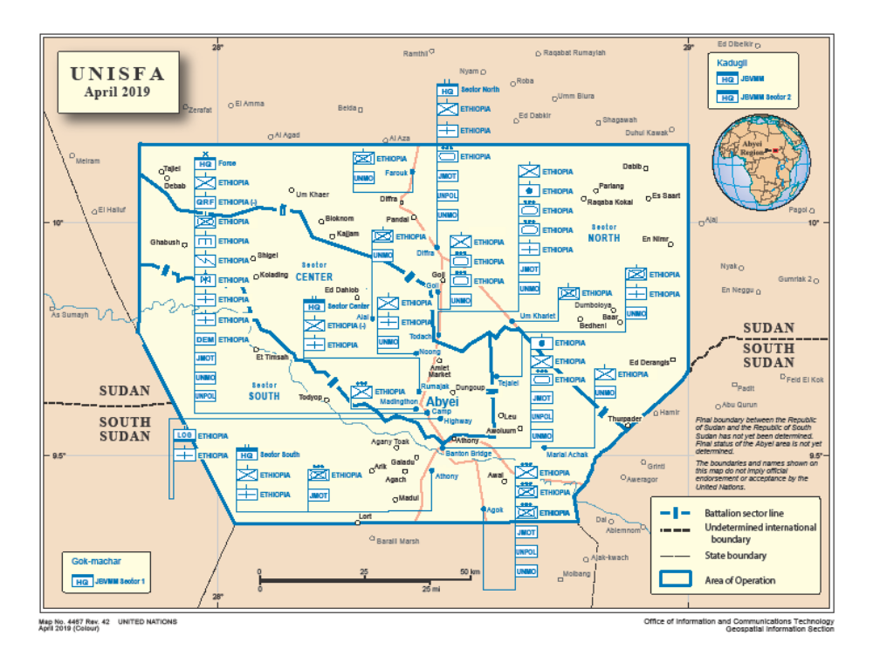
Abyei Hospital

Appendix VI. Introduction letter for Research

